MEGHNAD SAHA INSTITUTE OF TECHNOLOGY

*Techno Complex, Madurdaha,Beside NRI Complex, Post-Uchhepota, Kolkata 700 150*

LABORATORY NOTE BOOK

MAKAUT EVEN SEMESTER 2023



[BACHELOR OF COMPUTER APPLICATION]

[UNIX AND SHELL PROGRAMMING LAB (BCAC601)]

[RUPAK SARKAR]

ROLL NO: 31001221010 REGN. NO.: 213101001210001

STREAM: BCA SEMESTER: VI (6TH)

YEAR: 3RD YearSESSION: 2021-2024



MAULANA ABUL KALAM AZAD UNIVERSITY OF TECHNOLOGY



MEGHNAD SAHA INSTITUTE OF TECHNOLOGY

*Techno Complex,. Madurdaha,Beside NRI Complex, Post-Uchhepota, Kolkata 700 150*

“LIST OF ASSIGNMENT/EXPERIMENT SUBMISSION DETAILS”

|  |  |  |  |  |  |
| --- | --- | --- | --- | --- | --- |
| **SL.**  **NO.** | **ASSIGNMENT / EXPERIMENT NAME** | **PLANNED DATE OF SUBMISSION** | **ACTUAL DATE OF SUBMISION** | **CHECKED BY** | **REMARKS (ANY DEVIATION REGARDING SUBMISSION DATES, CONTENT, FORMAT, ETC)** |
| 1. | Introduction to VI Editor. | 18/03/2024 | 18/03/2024 |  |  |
| 2. | Different commands of VI Editor. | 18/03/2024 | 18/03/2024 |  |  |
| 3. | File Editing in VI Editor. | 18/03/2024 | 18/03/2024 |  |  |
|  |  |  |  |  |  |
|  |  |  |  |  |  |
|  |  |  |  |  |  |
|  |  |  |  |  |  |
|  |  |  |  |  |  |
|  |  |  |  |  |  |
|  |  |  |  |  |  |

|  |
| --- |
| OBSERVATIONS / COMMENTS ON THE OVERALL PERFORMANCE: |

Signature in full with date Signature in full with date

**Faculty / Technical Assistant Lab Examiner**

**Q.1 Introduction to Vi/Vim Editor.**

To create, edit or modify file, we use vi command.

The vi editor is elaborated as visual editor. It is installed in every Unix system. It is user-

friendly. It is a very powerful application. An improved version of vi editor is vim.

The vi editor has two modes:

**Command Mode:** In command mode, actions are taken on the file. The vi editor

starts in command mode. Here, the typed words will act as commands in vi

editor. To pass a command, you need to be in command mode.

**Insert Mode:** In insert mode, entered text will be inserted into the file.

The Esc key will take you to the command mode from insert mode.

By default, the vi editor starts in command mode. To enter text, you have to be in insert

mode, just type 'i' and you'll be in insert mode. Although, after typing i nothing will

appear on the screen but you'll be in insert mode. Now you can type anything.

To exit from insert mode press Esc key, you'll be directed to command mode.

If you are not sure which mode, you are in, press Esc key twice and you'll be in command mode.

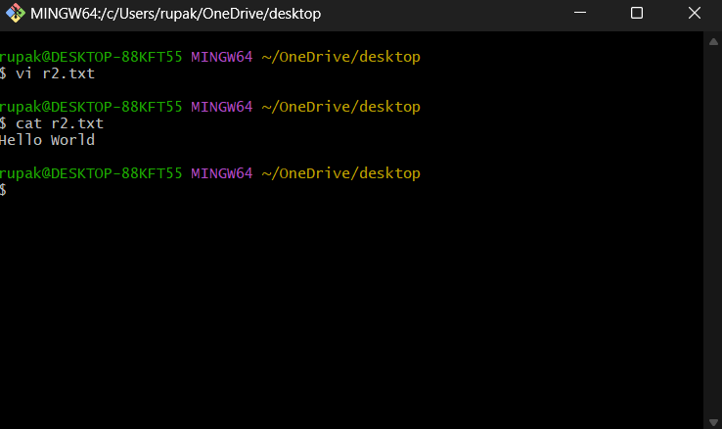

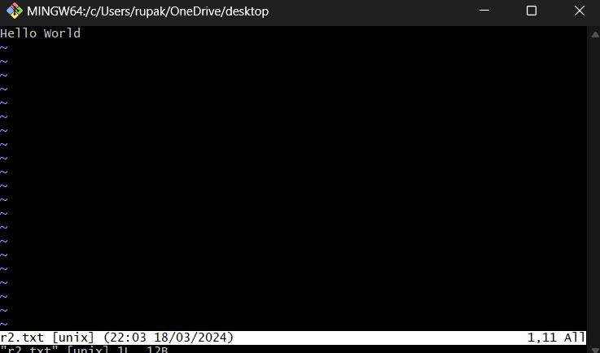

**Q.2. Different Commands of VI Editor?**

The `vi` editor is a popular text editor available in Unix-like operating systems. It provides a wide range of commands for creating, editing, and navigating text files. Here are some common commands used in `vi`:

**1. Entering and Exiting `vi`:**

- `vi filename`: Opens the file named "filename" in vi.

- `vi`: Opens vi without a file. You can then create a new file or open an existing one.

**2. Modes:**

- Command Mode: The default mode when you open vi. Used for navigating, searching, and executing commands.

- Insert Mode: Allows you to insert and edit text. Enter insert mode by pressing `i`, `I`, `a`, `A`, `o`, `O`, `r`, or `R`.

- Visual Mode: Allows you to select blocks of text for copying, cutting, or deleting. Enter visual mode by pressing `v`.

**3. Navigation:**

- `h`, `j`, `k`, `l`: Move the cursor left, down, up, and right respectively.

- `Ctrl + f`: Move forward one page.

- `Ctrl + b`: Move backward one page.

- `0` (zero): Move to the beginning of the current line.

- `$`: Move to the end of the current line.

- `gg`: Move to the beginning of the file.

- `G`: Move to the end of the file.

**4. Editing:**

- `x`: Delete the character under the cursor.

- `dd`: Delete the current line.

- `yy`: Yank (copy) the current line.

- `p`: Paste the yanked or deleted text after the cursor position.

**5. Searching and Replacing:**

- `/pattern`: Search forward for the next occurrence of "pattern".

- `?pattern`: Search backward for the previous occurrence of "pattern".

- `n`: Move to the next occurrence of the search pattern.

- `N`: Move to the previous occurrence of the search pattern.

- `:s/pattern/replacement/g`: Replace "pattern" with "replacement" globally in the file.

**6. Saving and Exiting:**

- `:w`: Save changes to the file.

- `:q`: Quit vi (exit).

- `:wq` or `:x`: Save changes and quit.

- `:q!`: Quit vi without saving changes (force quit).

These are just some of the basic commands in vi. The editor has many more features and commands for advanced text editing and manipulation.

**Q.3. File Editing in VI Editor.**

**VI Editing commands**

* i - Insert at cursor (goes into insert mode)
* a - Write after cursor (goes into insert mode)
* A - Write at the end of line (goes into insert mode)
* ESC - Terminate insert mode
* u - Undo last change
* U - Undo all changes to the entire line
* - Open a new line (goes into insert mode)
* dd - Delete line
* 3dd - Delete 3 lines.
* D - Delete contents of line after the cursor
* C - Delete contents of a line after the cursor and insert new text. Press ESC key to end insertion.
* dw - Delete word
* 4dw - Delete 4 words
* cw - Change word
* x - Delete character at the cursor
* r - Replace character
* R - Overwrite characters from cursor onward
* s - Substitute one character under cursor continue to insert
* S - Substitute entire line and begin to insert at the beginning of the line
* ~ - Change case of individual character

